Hello Members,
Due to the added work involved in processing NON- BTRA registrations (both foreign and domestic) BTRA is implementing a price increase; (1) Non-BTCA members $50.00, (2) BTCA members $40.00 Regular BTRA registrations will remain same. The new prices and rules will go into effect today, April 6, 2018. This will not affect registrations that have already been issued.
We have received clarification from AKC on the 3 generation pedigree rule for advancement into the Misc. group. The following graph is from AKC. I will be correlating the AKC terms to the Ancestry charts from the Wisdom Panel.
AKC THREE GENERATION GUIDE FOR MISC ACCEPTANCE
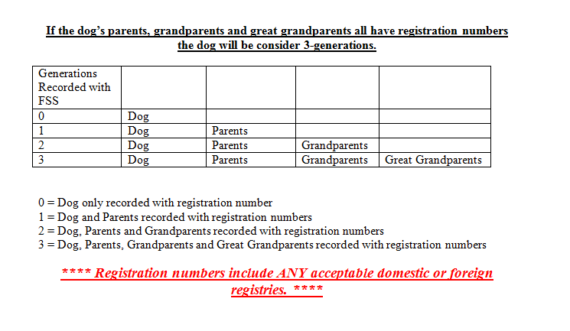

Registering Foreign and Domestic Dogs Requiring the Mars Wisdom Panel Test for Purebred Registration
The Wisdom Panel has 7 separate tests that are considered when determining the purebred status of a dog. Because of the genetics behind the test, BTRA acknowledges the purity of a dog if it passes 5 of those tests. You may not see all the individual tests but the results will say the dog passes. BTRA registrations will be listing the registration numbers assigned each dog in the pedigree if it has been deemed 100% purebred. If there is an “inconclusive” on the Ancestry Chart, only the Biewer Terriers will get a registration number. If there is a Yorkie pictured in one of the generations, No registration numbers will be listed on any dog in that line. This does not mean that a Yorkie was used in the breeding of a dog. It means that every so often, a little piece of DNA may show similar qualities.
Mars Diagram  Reg. No# 0 =  Reg. No# 1 =  Reg. No# 2 =  Reg. No# 3 = | 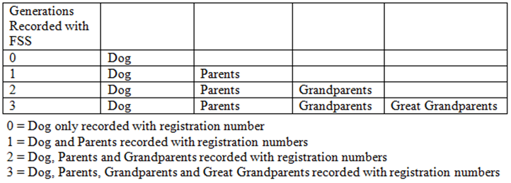

These charts will correlate with the AKC explanation of what a generation is. In the diagram you will see a single dog is a “0” generation. The big round circle represents the dog you are registering. This chart is an example of a full 3 generations.
All dogs have a reg. No#  The dog that is being registered is a 0 gen. This dog will receive a BTRA No#  A dog & parents are 1 generation. The Reg. No# 1 signifies the first generation.  A dog, parents and grandparents are 2 gen’s.  A dog, parents, GP’s and great –GP’s makes 3 generations | 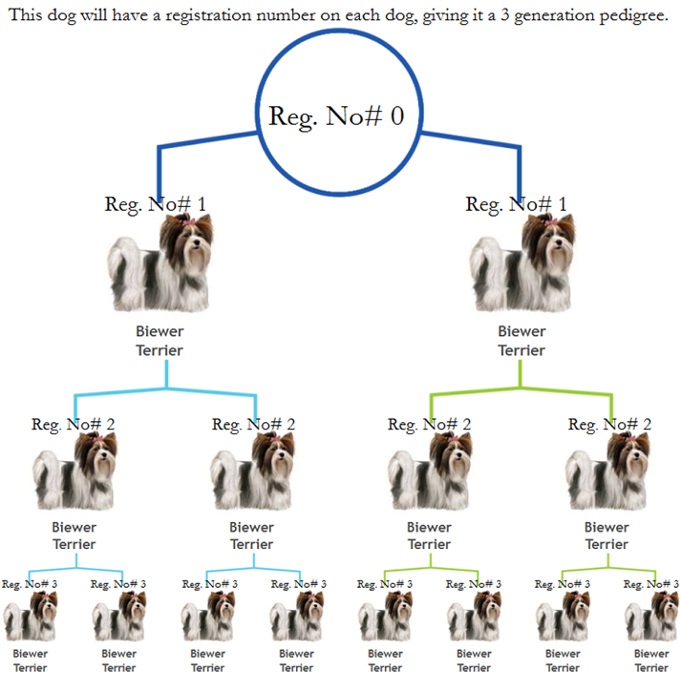

I have removed some registrations numbers from this pedigree to use as an example of “1” generation.
BTRA pedigree  The dog and the parents have registration No#’s  The grandparent’s line has 1 dog that does not have a Reg. No#. That eliminates it from being a generation. | 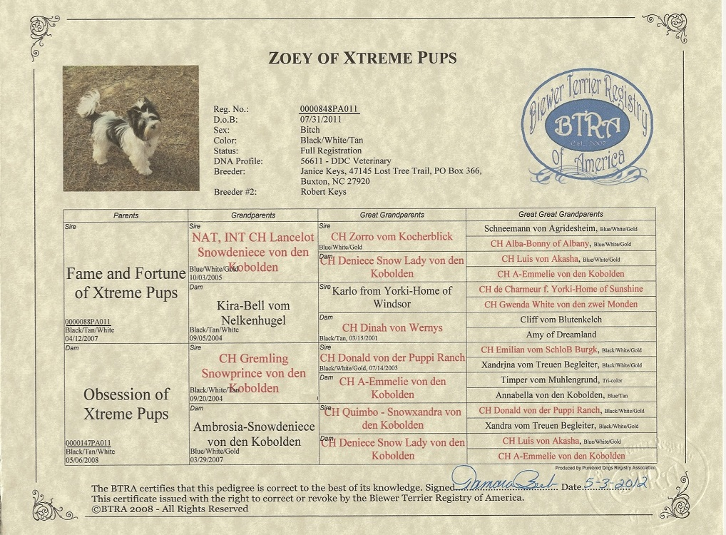

Zoey  Fortune & Obsession  From now on BTRA will not put a Reg No# on any dog in the line because one dog is inconclusive. | 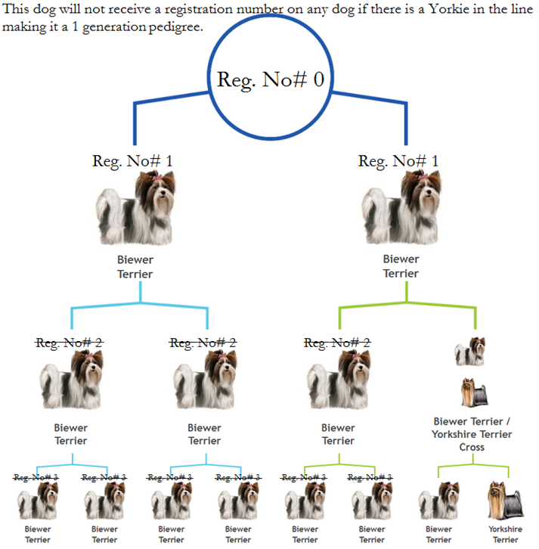

If you have any questions, we will be happy to address any concern you may have.
Thank you, Gayle

